MINI PROJRCT
DOCUMENTATION

NAME: HARITHA HARI
BATCH: 69

I have chosen the data set Supermarket Sale.

URL:
https://www.kaggle.com/datasets/bcscuwe1/supermarket-sales

Above mentioned is the raw dataset of super market sales. I have chosen this dataset for creating insights and learning about the structured business data with more than 10 columns and 1000 rows.
This supermarket sales dataset can provide valuable insights into business performance and customer behaviour. By analysing product lines, branches, and cities, we can identify which categories and locations generate the most revenue and profit. Customer demographics such as gender and membership type reveal spending patterns and preferences, while payment methods highlight transaction trends.
Altogether, the dataset supports decisions on sales strategy, customer targeting, and operational improvements.

DATA CLEANING

There are some missing values in the column “Customer type”. Here there are only two values in this column “Normal” and “Member”, So the easiest method is to use COUNTIF Function to find the number of individual items and then use MODE function to fill the blank cells.
Here the most frequent occurring item is “Normal” in “Customer type” column. So we can fill the empty cells with “Normal”.
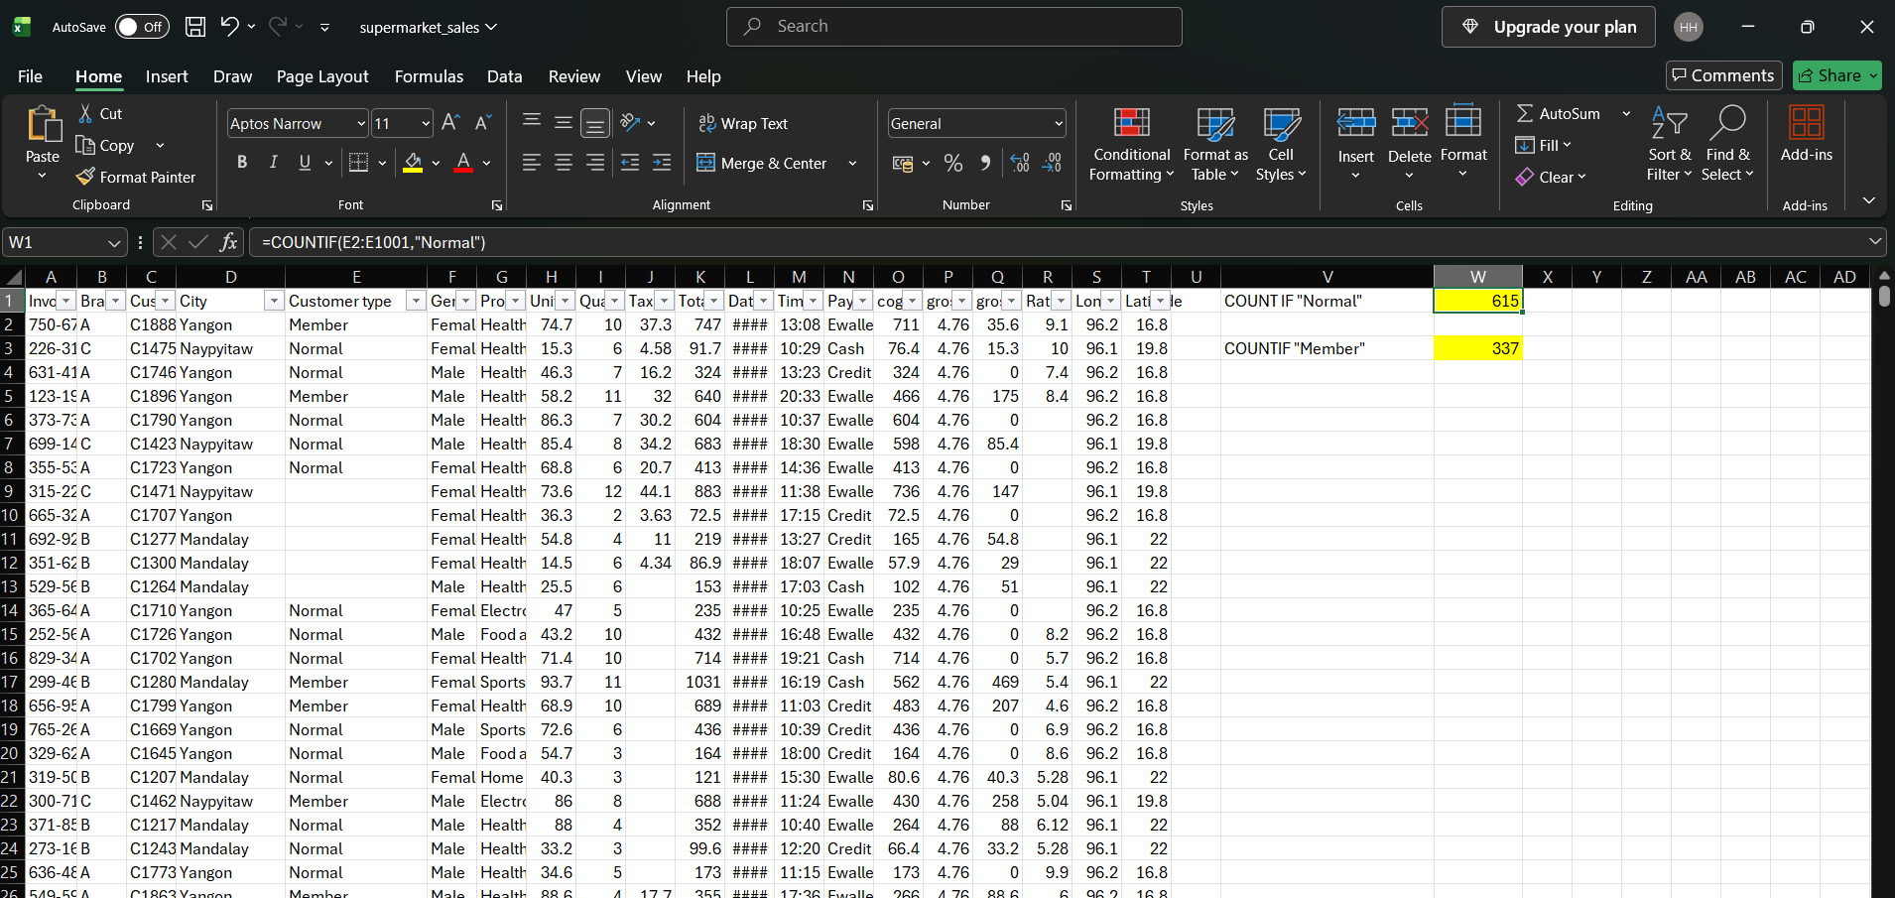
Formula used : =COUNTIF(E2:E1001,"Normal")
=COUNTIF(E2:E1001,"Member")
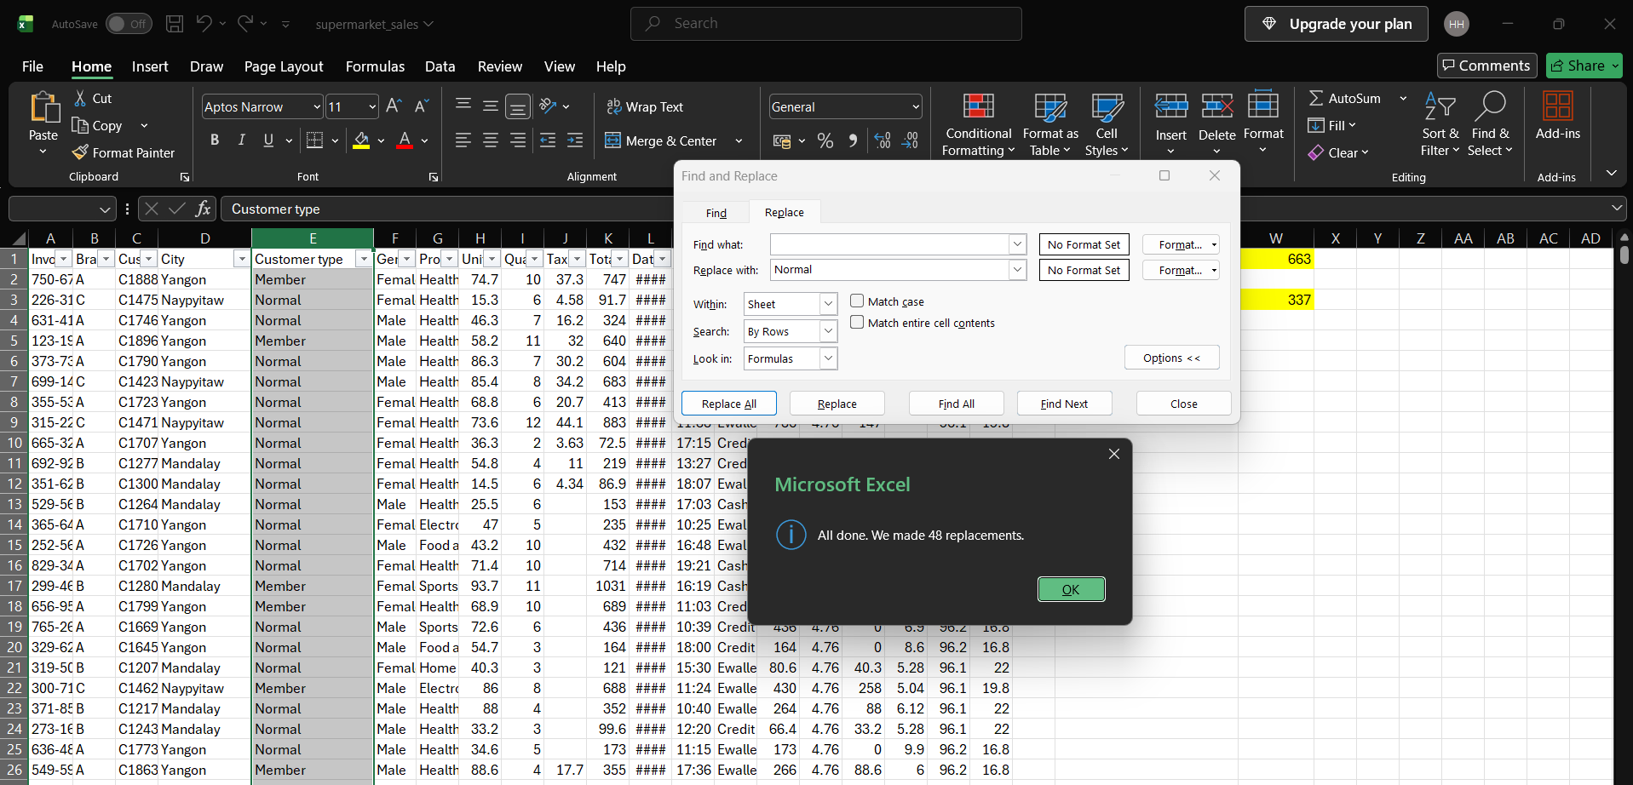

Same case is used to fill the next two columns “Gender” and “Product line”.
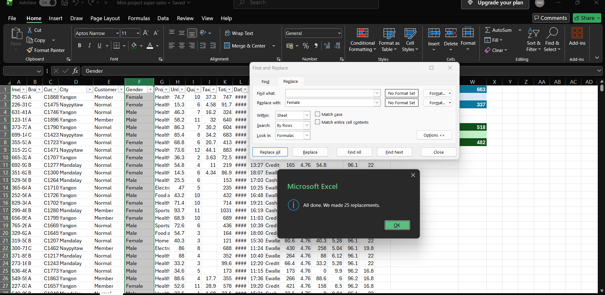

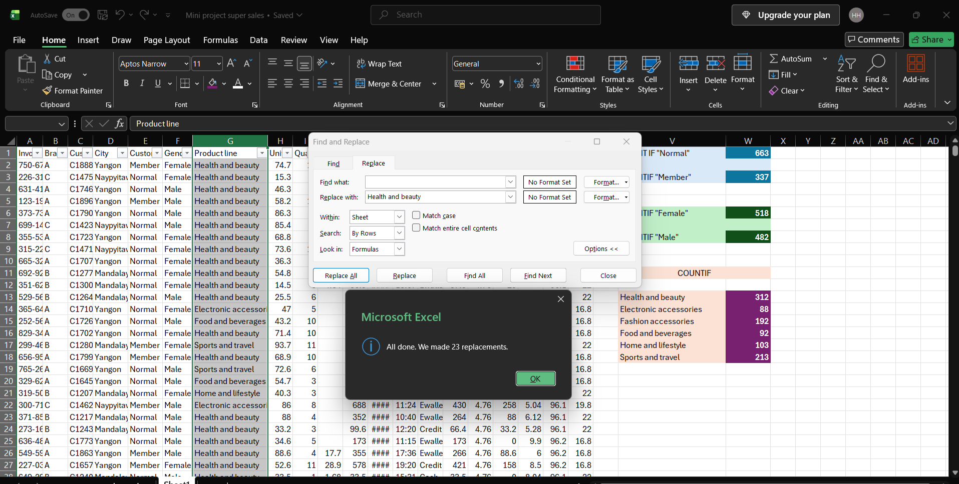

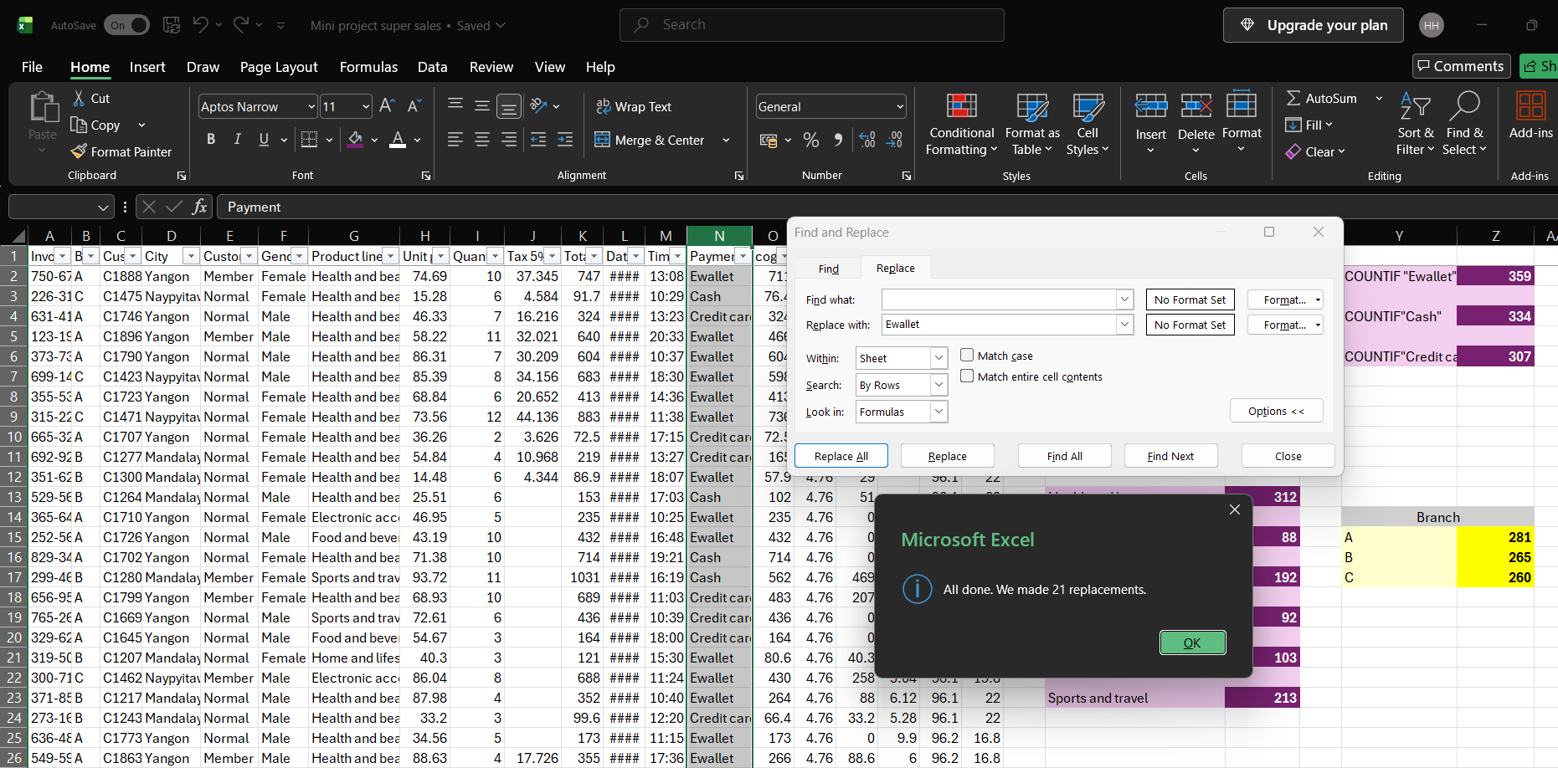

We can also use the filter to find the count.

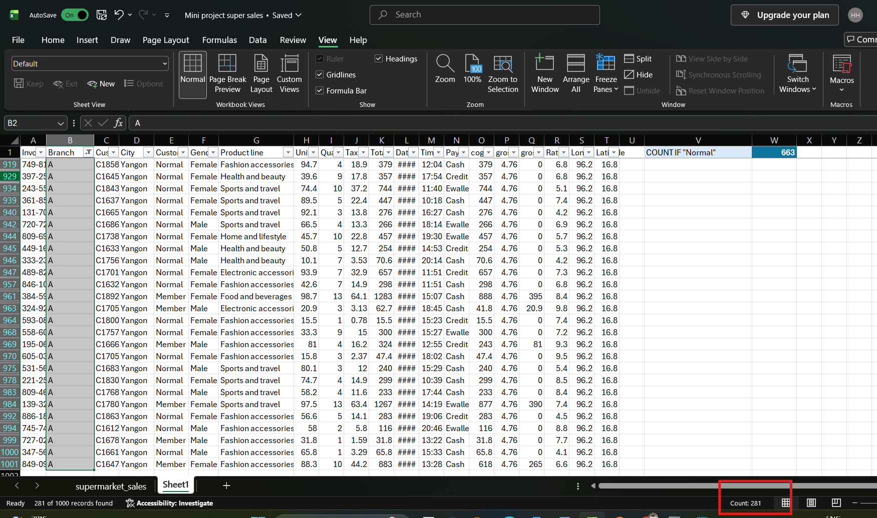

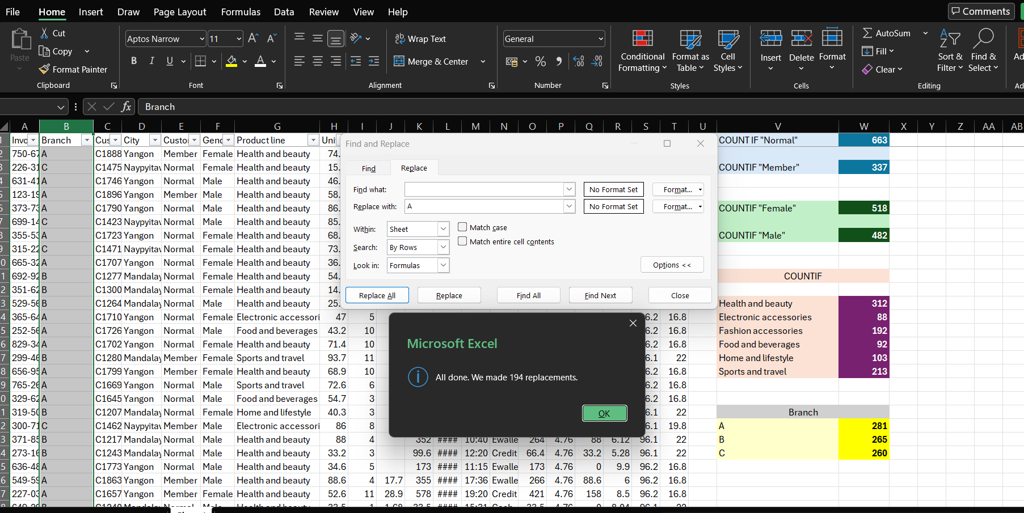

There are no duplicate values in the dataset.

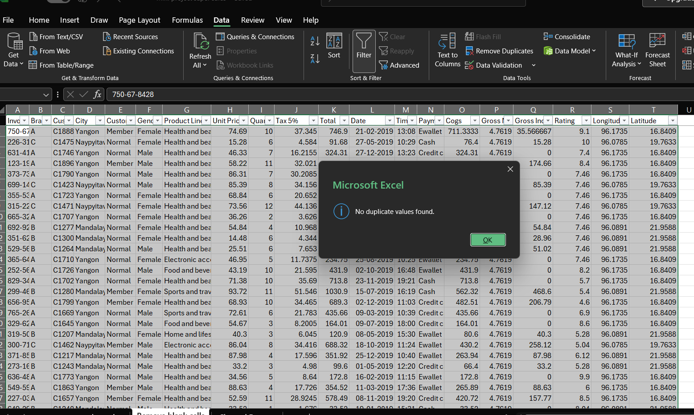

The column named “Tax 5%” is not complete.
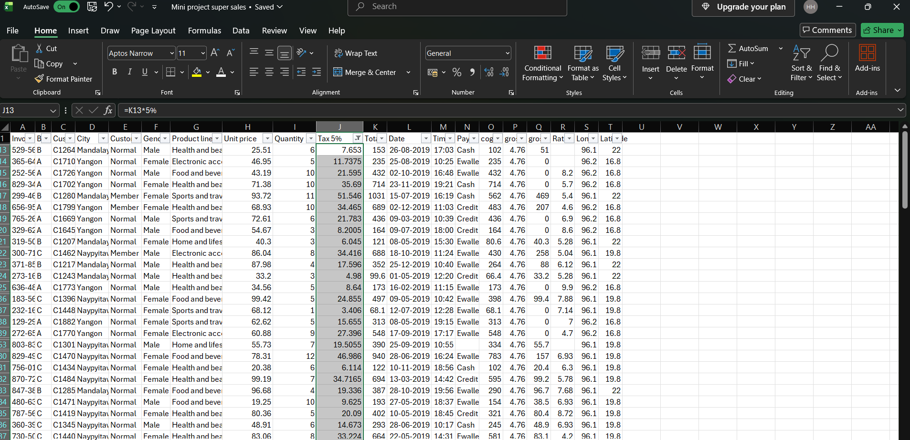
Formula used: =K19*5%

To fill the column named “Rating” , we have to find the average.
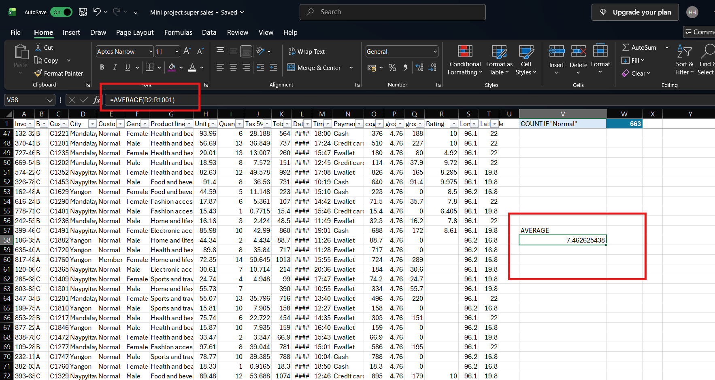

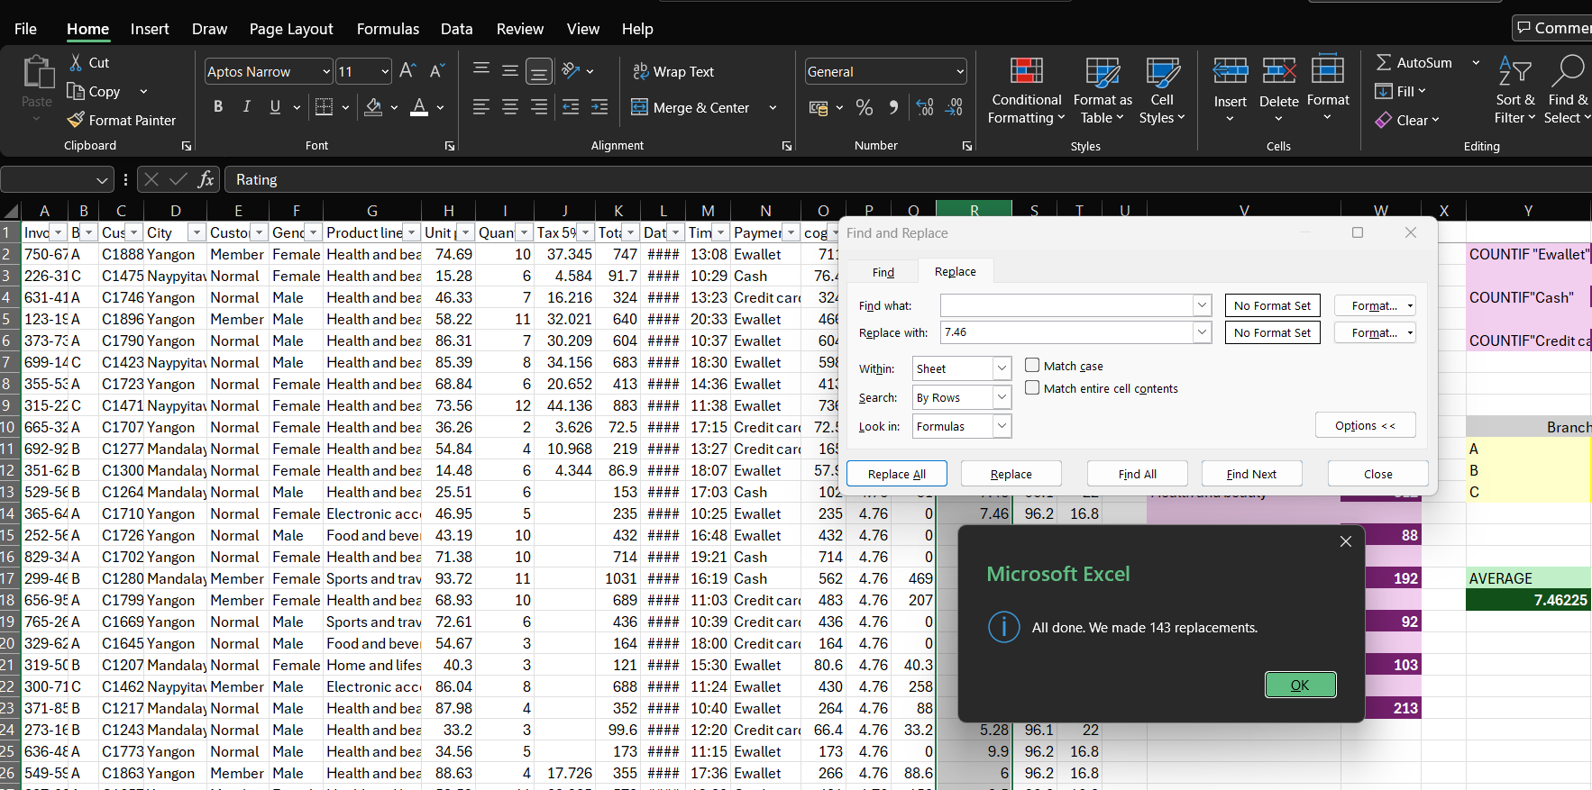

Standardizing formats
We have to make the headings of each column into proper case using the Function PROPER.

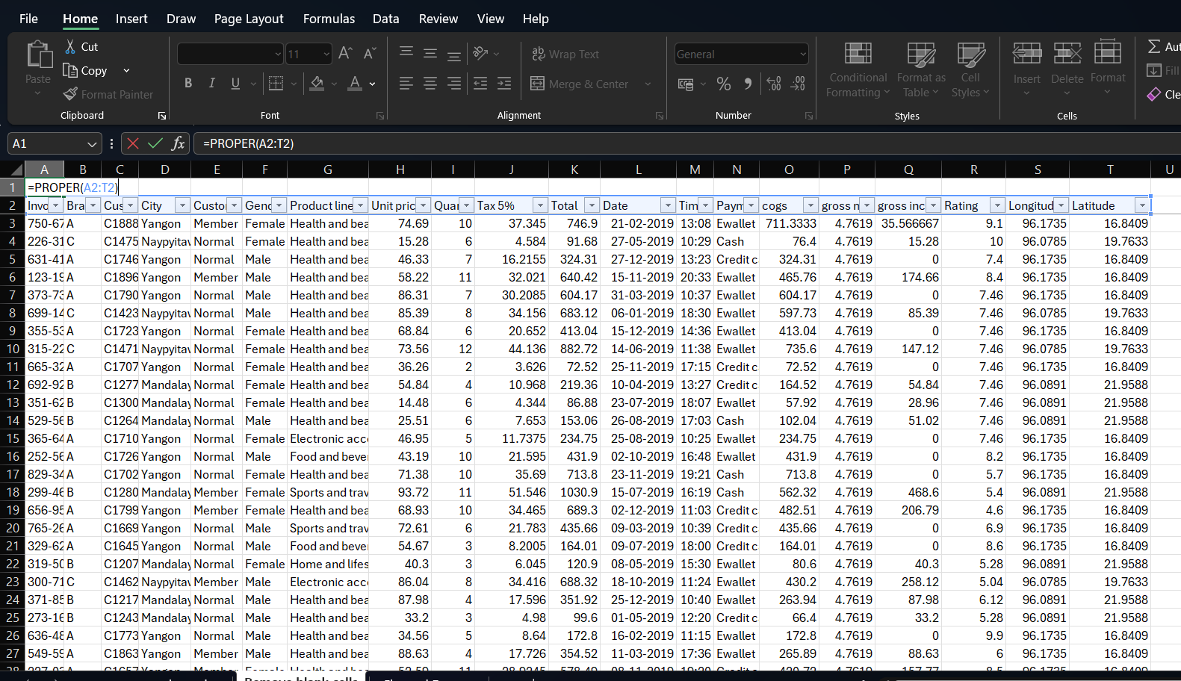

Finally convert the cleaned dataset into a table format (Select the data- Insert-Table)

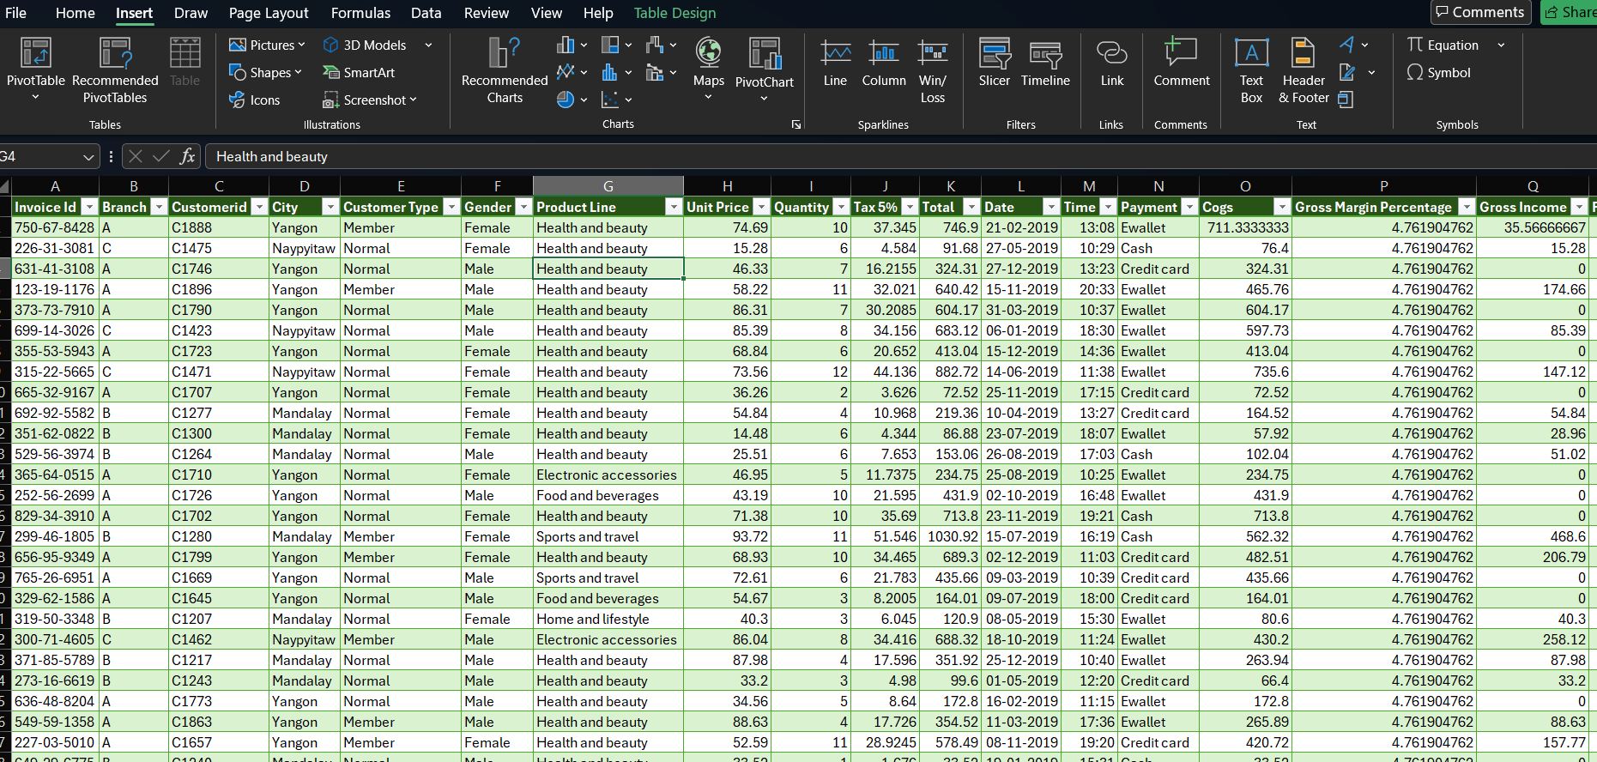

Pivot Tables:
Here I have created pivot tables to summarize, analyse and visualize the dataset in a structured and dynamic way. It will help to derive insights and present information in a clear and meaningful manner.

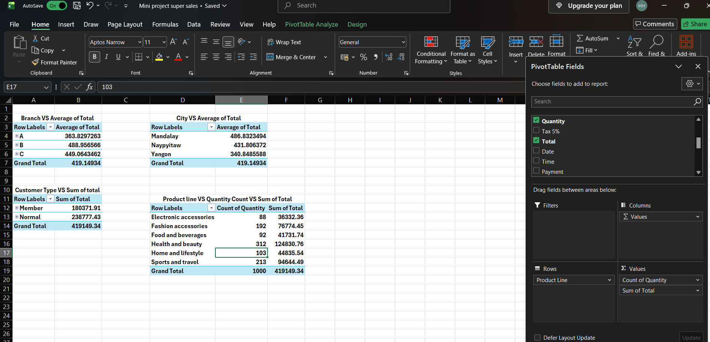
Branch VS Average of Total

This table gives an idea about the average of total amount obtained from each branch, This table includes customer type, so that I will be easy to find the average of each branch with customer type with in that.

Customer Type VS Sum of total

This table is also about the total sum of customer type,as the previous table Gender is also added in the row, so it will be easy to find the total sum of sales on gender basis.

The other two tables are also about the comparison of fields, so that we can derive the insight easily from that and also easy to present.

Data Visualization using Power BI

Cleaned data set is loaded into power BI desktop.

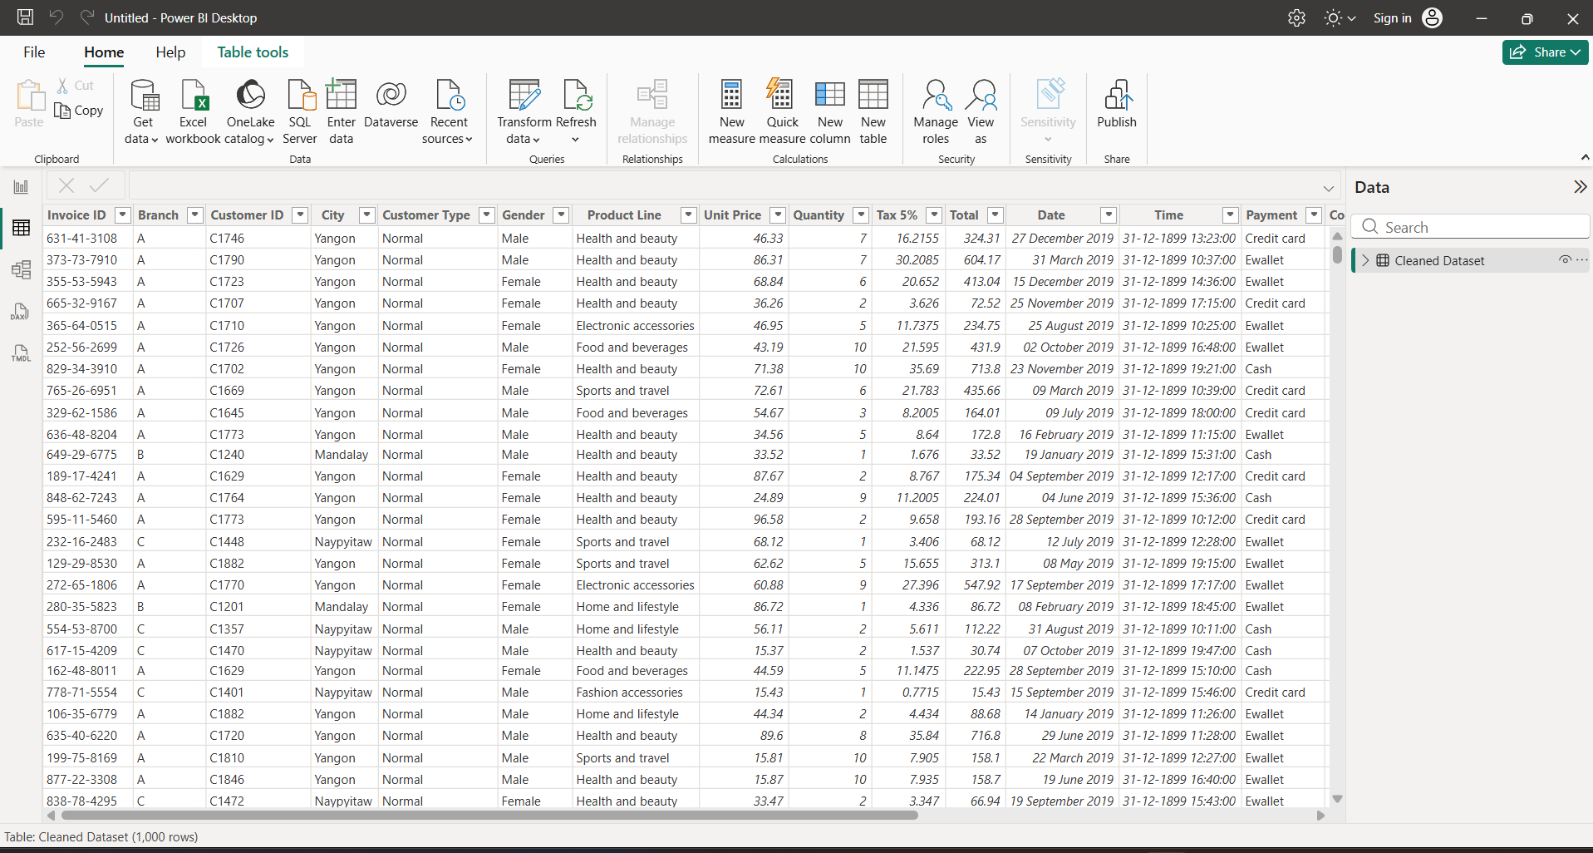

For adding heading I have selected Text Box from Home tab
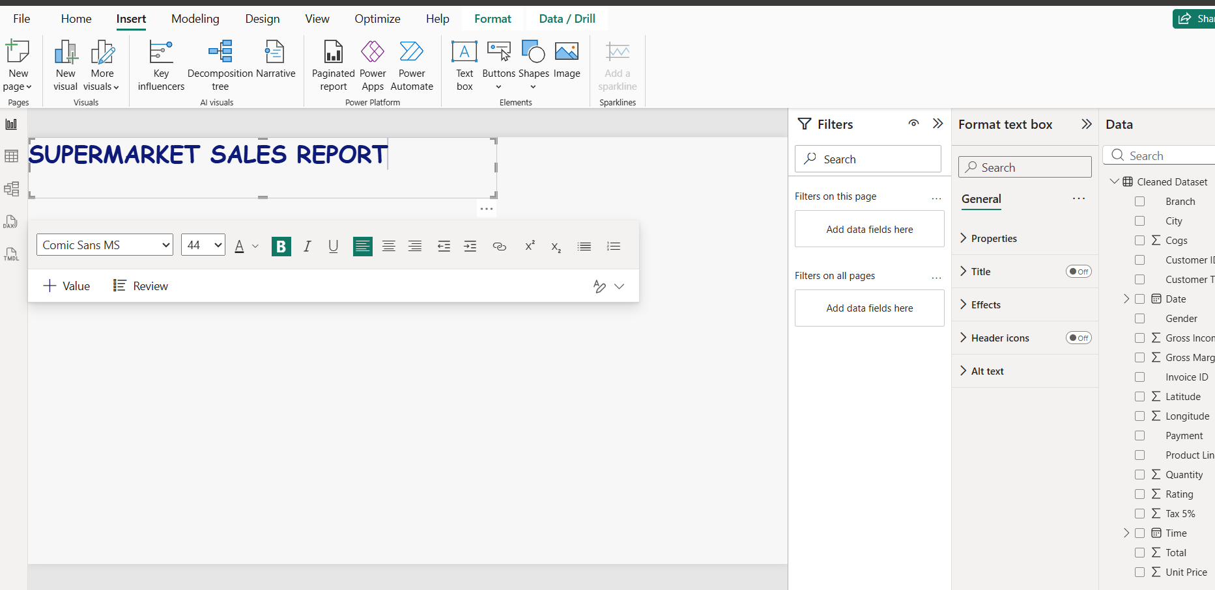

For adding images selected Image from Insert tab and then choose from the downloads

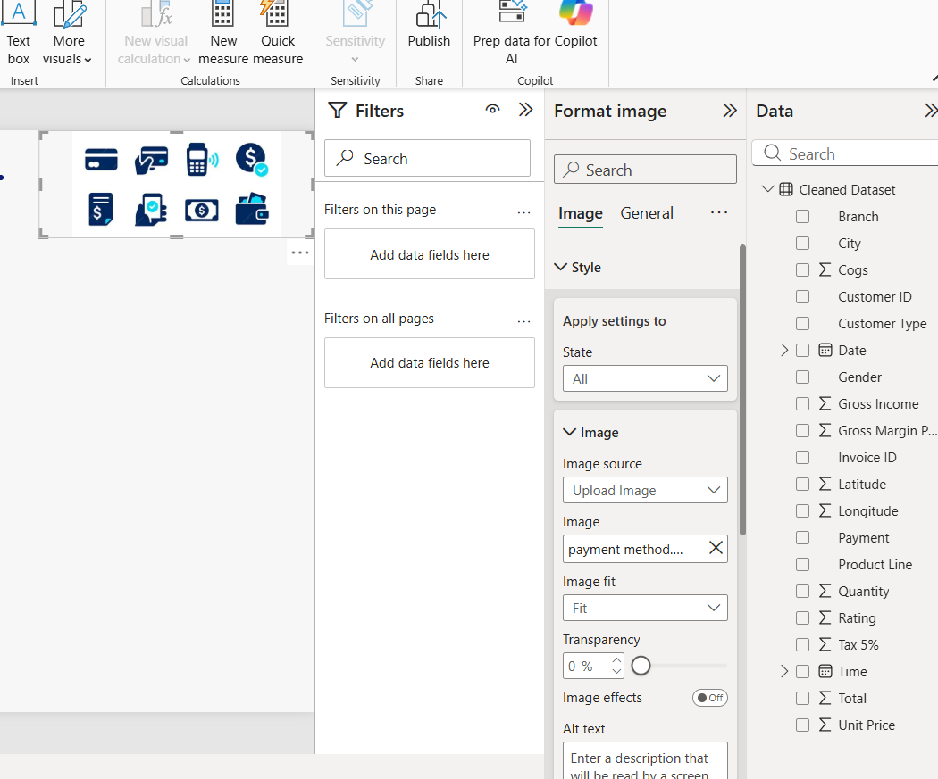

For making the dashboard more informative, I have added bar chart, line chart, donut chart and column chart
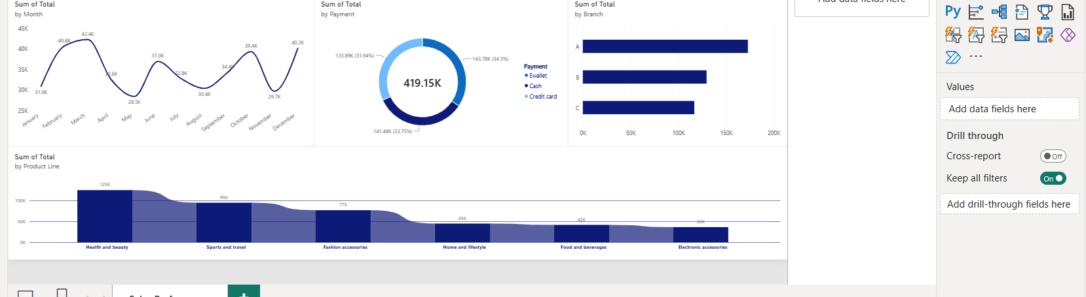

Cards are very helpful for understanding the total or sum of the sales and quantity of items purchased.
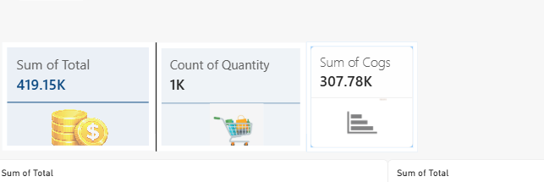

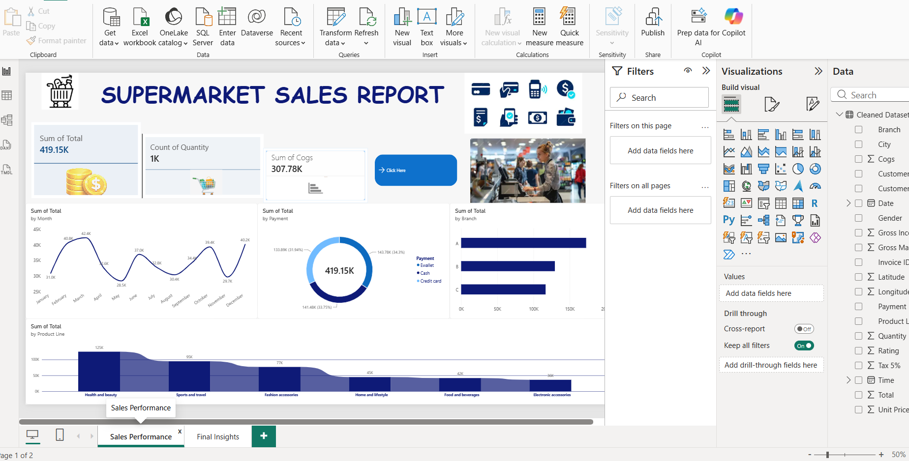

Final insight dashboard is created and that contains “Tables” , “Tree map” and so on. Table will give an overview of the customers on gender basis.
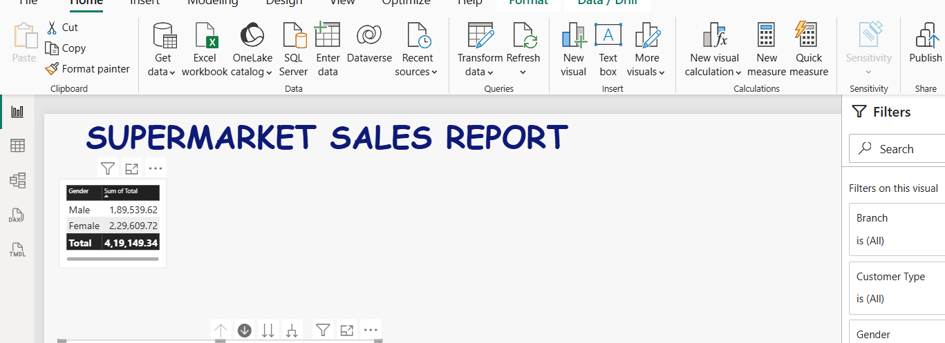

For tree map I have selected customer type and gender and branch total sales, Dill through function will work on this.
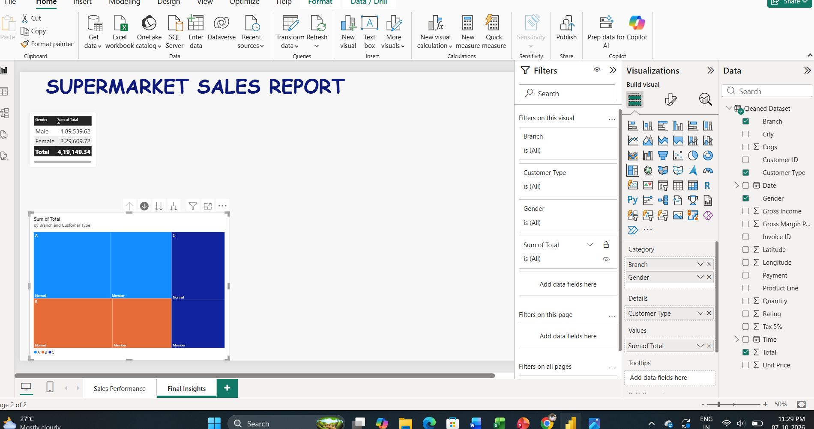

Maps and pie chart also added
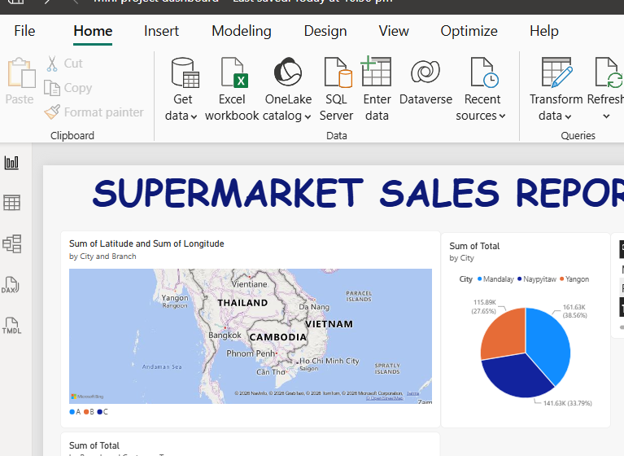

Pie chart is added between city and total sales, so that city wise sales can be identified.
Maps will help to show the sales in particular region using branch and city also with the longitude and latitude.

Slicers added and also the donut chart will give the total sales of the product line.
